

**Product Dissection for Facebook**

**Company Overview**

Founded by Mark Zuckerberg and his college roommates in 2004, Facebook has grown from a college networking site to a global social media giant. Known for its extensive user base and multifaceted platform, Facebook connects people from all over the world, allowing them to share content, communicate, and engage with various communities. As a subsidiary of Meta Platforms, Inc., Facebook continues to innovate and adapt to the ever-evolving digital landscape.

**Product Dissection and Real-World Problems Solved by Facebook**

Facebook addresses numerous real-world challenges through its comprehensive suite of features. By focusing on user engagement and connectivity, Facebook has created a platform that fosters relationships, facilitates communication, and provides a space for community building.

1. **Disconnect in Digital Relationships**
   * **Real-World Challenge**: Increasing digitalization has led to a lack of genuine connections in online interactions.
   * **Facebook's Solution**: By enabling users to share photos, videos, statuses, and stories, Facebook creates a diverse environment for expressing personal experiences. This allows users to connect on a deeper level, nurturing meaningful relationships through likes, comments, and shares.
2. **Information Overload**
   * **Real-World Challenge**: The vast amount of content available online can overwhelm users.
   * **Facebook's Solution**: The News Feed uses advanced algorithms to curate a personalized stream of content from friends, pages, and groups that users follow. This ensures that users see relevant and engaging content, mitigating the problem of information overload.
3. **Community Building**
   * **Real-World Challenge**: People often struggle to find and engage with communities that share their interests and values.
   * **Facebook's Solution**: Facebook Groups provide a space for users to join communities based on shared interests, hobbies, or goals. This fosters a sense of belonging and allows users to engage in discussions, share content, and organize events within their communities.
4. **Event Planning and Coordination**
   * **Real-World Challenge**: Coordinating events and gatherings can be challenging, especially for large groups.
   * **Facebook's Solution**: The Events feature allows users to create, manage, and promote events. Users can invite friends, track RSVPs, and share event details, making it easier to organize social and professional gatherings.
5. **Marketplace for Local Commerce**
   * **Real-World Challenge**: Finding a reliable platform for buying and selling items locally can be difficult.
   * **Facebook's Solution**: The Marketplace feature provides a platform for users to buy and sell items within their local communities. This facilitates local commerce and offers users a convenient way to find and purchase goods.

**Top Features of Facebook**

1. **User Profiles**: Facebook allows users to create personal profiles, offering insights into their lives through features such as profile pictures, cover photos, bios, and friend lists. This creates a personalized online presence that reflects each user's identity.
2. **Posts**: Users can share various types of content, including text updates, photos, videos, and links. Posts can be accompanied by captions, locations, and tags.
3. **Interactions**: Users can engage with content through likes, comments, and shares. The "Save" feature allows users to bookmark content for later viewing.
4. **Friends and Following**: Users can connect with others by sending friend requests or following public profiles. This creates a network of connections and allows users to see each other's content.
5. **Groups**: Users can join or create groups to engage with communities that share their interests. Groups provide a space for discussion, content sharing, and event planning.
6. **Events**: The Events feature enables users to create, manage, and promote events. Users can invite friends, track RSVPs, and share event details.
7. **Marketplace**: The Marketplace allows users to buy and sell items within their local communities, facilitating local commerce.
8. **Messenger**: Facebook Messenger is an integrated chat service for messaging, voice, and video calls. It supports group chats, multimedia sharing, and more.
9. **Stories**: Users can share temporary photo and video posts that disappear after 24 hours, providing a more casual and ephemeral way to share content.

**Schema Description**

The schema for Facebook involves multiple entities representing different aspects of the platform. These entities include Users, Posts, Comments, Likes, Friends, Groups, Events, Marketplace Listings, and more. Each entity has specific attributes that describe its properties and relationships with other entities.

· **User Entity**:

* **UserID**: (Primary Key): A unique identifier for each user.
* **Username**: The chosen username for the user's account.
* **Email**: The user's email address for account-related communication.
* **Full_Name**: The user's full name as displayed on their profile.
* **Bio**: A brief description that users can use to express themselves.
* **Registration_Date**: The date when the user joined Facebook.

**Post Entity**:

* **PostID**: (Primary Key): A unique identifier for each post.
* **UserID**: (Foreign Key referencing User Entity): The user who created the post.
* **Content**: The text, image, or video content of the post.
* **Caption**: Text accompanying the post, providing context.
* **Location**: The tagged location associated with the post.
* **Post_Date**: The date when the post was created.

**Comment Entity**:

* **CommentID**: (Primary Key): A unique identifier for each comment.
* **PostID**: (Foreign Key referencing Post Entity): The post being commented on.
* **UserID:** (Foreign Key referencing User Entity): The user who posted the comment.
* **Text**: The text of the comment.
* **Comment_Date**: The date when the comment was posted.

**Like Entity**:

* **LikeID:** (Primary Key): A unique identifier for each like.
* **PostID:** (Foreign Key referencing Post Entity): The post being liked.
* **UserID:** (Foreign Key referencing User Entity): The user who liked the post.
* **Like_Date**: The date when the like was registered.

**Friend Entity**:

* **FriendID:** (Primary Key): A unique identifier for each friend relationship.
* **UserID1:** (Foreign Key referencing User Entity): The first user in the friendship.
* **UserID2:** (Foreign Key referencing User Entity): The second user in the friendship.
* **Friend_Date**: The date when the friendship was established.

**Group Entity**:

* **GroupID:** (Primary Key): A unique identifier for each group.
* **GroupName**: The name of the group.
* **Description**: A brief description of the group's purpose.

**GroupMember Entity**:

* **GroupMemberID:** (Primary Key): A unique identifier for each group membership.
* **GroupID:** (Foreign Key referencing Group Entity): The group being joined.
* **UserID:** (Foreign Key referencing User Entity): The user joining the group.
* **Join_Date**: The date when the user joined the group.

**MarketplaceListing Entity**:

* **ListingID** (Primary Key): A unique identifier for each marketplace listing.
* **UserID** (Foreign Key referencing User Entity): The user who created the listing.
* **Item_Name**: The name of the item being sold.
* **Description**: A brief description of the item.
* **Price**: The price of the item.
* **Listing_Date**: The date when the listing was created.

**ER Diagram**

To visualize the relationships and attributes of the entities within the Facebook schema, we can construct an ER diagram. This diagram will depict the connections between users, posts, comments, likes, friends and groups, highlighting the interactions and dependencies within the platform.

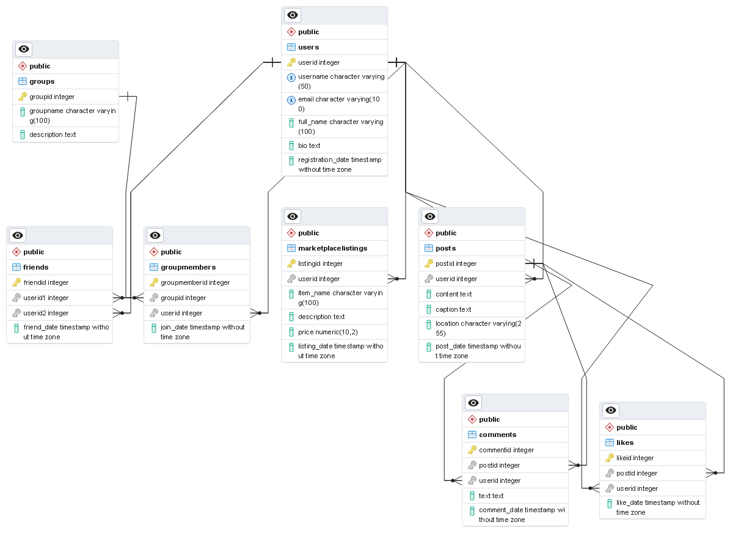

**Conclusion**

In this case study, we dissected the design of Facebook's product and its schema. Facebook has successfully addressed various real-world challenges by promoting genuine connections, curating content, building communities, facilitating event planning, and supporting local commerce. The intricate data model, consisting of entities like users, posts, comments, likes, friends, groups, events, and marketplace listings, forms the foundation for Facebook's functionality. Understanding this schema provides insight into how Facebook manages user interactions and content sharing, contributing to its widespread popularity and continued growth in the social media domain.